Summer Treasure Hunt – Silent Auction

After a fantastic day back in the summer we are now holding a silent auction of the animals to raise more money for our charity. These are the animals which are being auctioned:

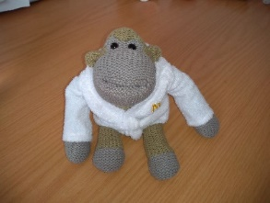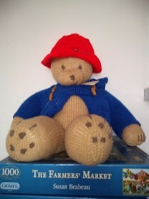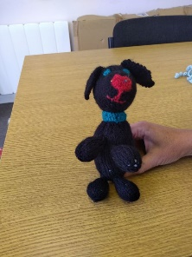

Horace - Monkey

Gilbert – Paddington ‘Style’ Bear

Milly – Black Dog

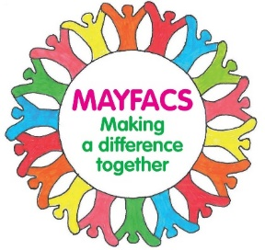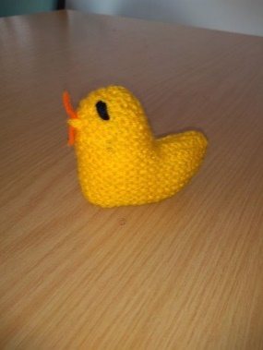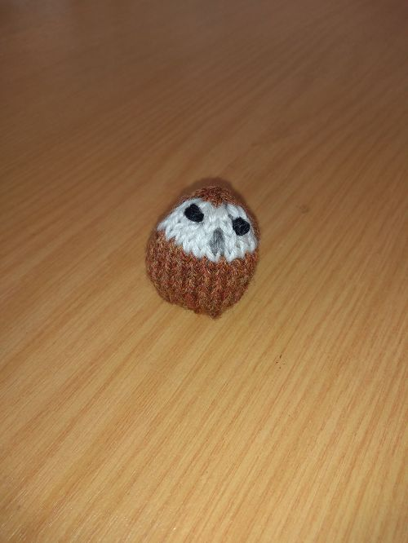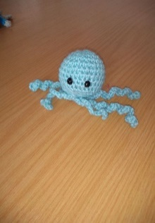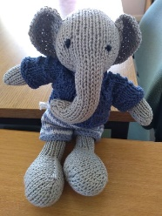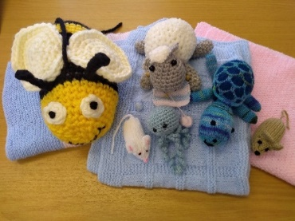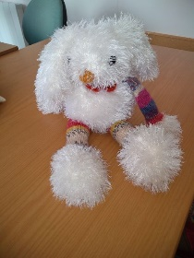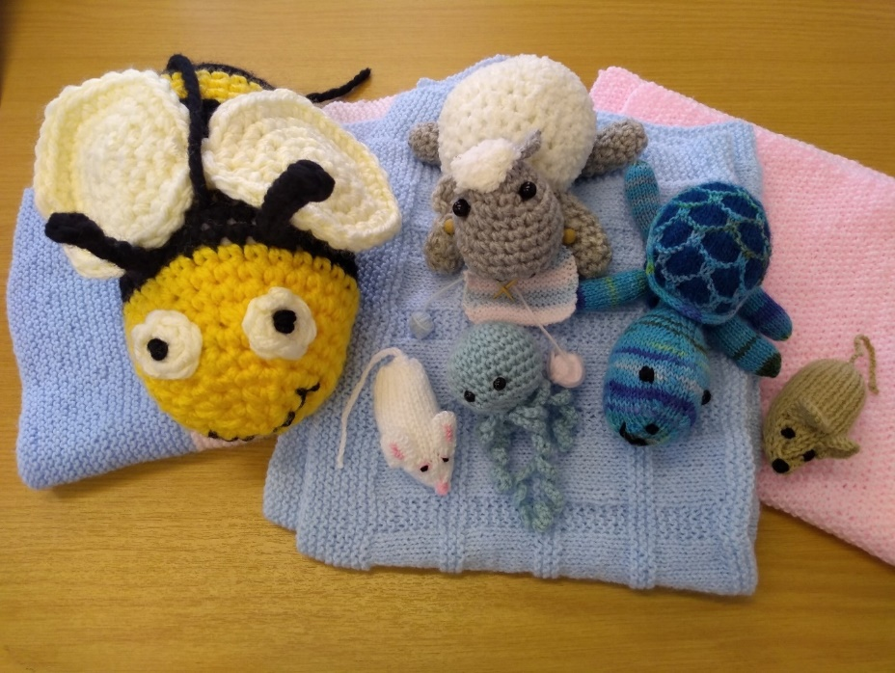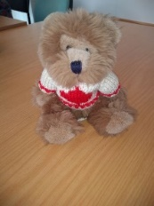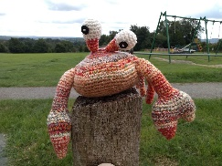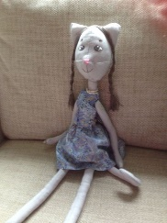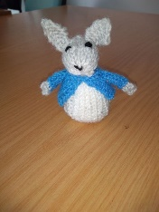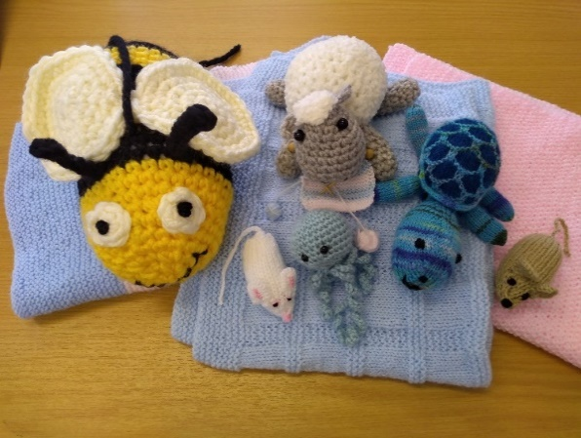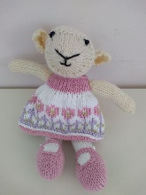

Please select the animal or animals you wish to bid for and pop into the MAYFACS office along with your sealed envelope. Please include your name, telephone number/email address, name of the animal and the bid amount. *The MAYFACS Office is situated next to the Mayfield Memorial Hall.*

The auction closes on 26th of November.

You can bid on more than one animal but only one bid per animal.

If your bid is successful, we will contact you via the method you have chosen.

Daphne - Chick

Bertie – Bee

Ariel - Rabbit

Toffee – Brown Mouse

Spike - Bear

Toto - Crab

Scampi - Cat

Fizzy - Rabbit

Tarquin – Tortoise

Pippa - Lamb

Alfie – Owl

Casper – Octopus

Coco – Elephant