MAYFIELD & FIVE ASHES COMMUNITY SERVICES
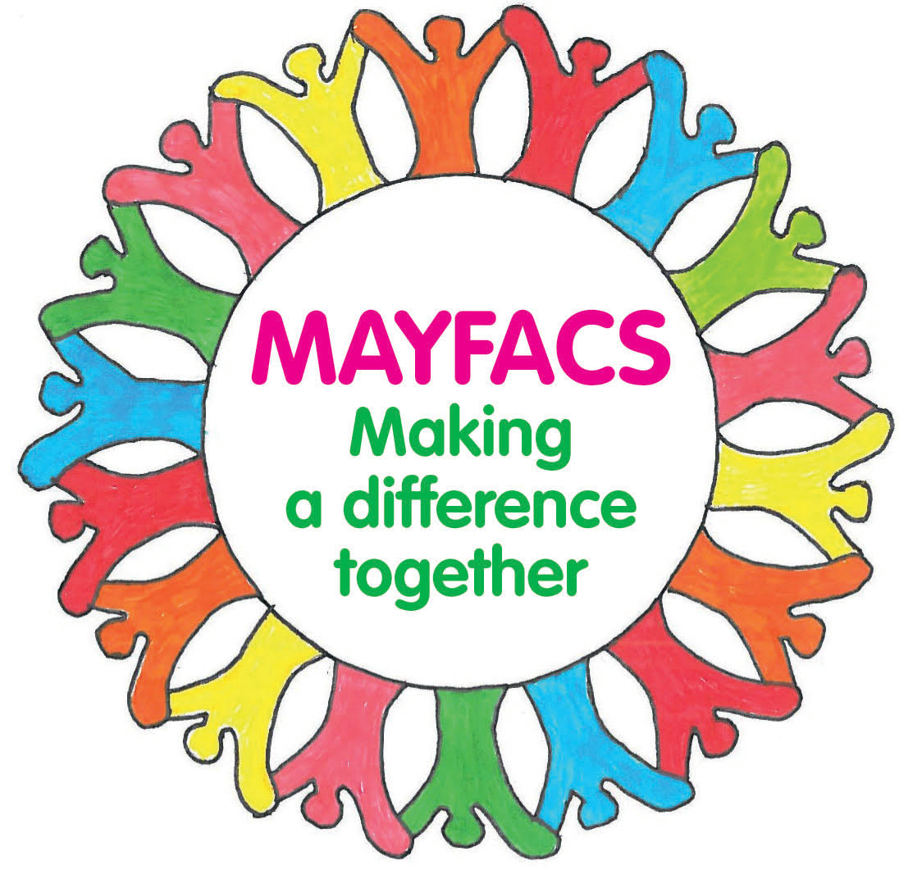
DONATION & GIFT AID FORM

I have made an on-line bank transfer of £……………………………….
to MAYFACS, Sort Code 40-52-40 Account No. 00029924 (CAF Bank)
(Please consider gift aiding your donation if you are a tax-payer, scan & email this form to Charles Marshall, c.h.marshall@btinternet.com)

OR

I enclose a cheque for £…………………… made payable to
“Mayfield & Five Ashes Community Services”.
Please send to: Charles Marshall, Woodreed Farm, Stonehurst Lane, Five Ashes, Mayfield TN20 6LJ or bring to the MAYFACS Office.

I wish to make this donation using Gift Aid and have signed the Gift Aid declaration form below.

I give permission for MAYFACS to hold my personal data and update me occasionally about their activities.
A copy of our privacy & data protection policy is on our website or a hard copy is available upon request.

Name………………………………………………………………………………………………………………………………………

Address……………………………………………………………………………………………………………………………………

……………………………………………………… Post Code……………………………………………

Gift Aid Declaration in favour of Mayfield & Five Ashes Community Services (MAYFACS). Registered charity number 1166647

I (full name)……………………………………………………………………….. address above
hereby state that all donations I make hereafter to Mayfield and Five Ashes Community Services are to be treated as ‘Gift Aid Donations’ and I wish Mayfield and Five Ashes Community Services to reclaim the tax on the donations.
I declare that I pay income tax or capital gains tax equal to the tax deducted from my donation.
I will advise you of any change in the above information and should I wish to cancel this declaration in the future.

Signature……………………………………………………………. Date……………………………………………

